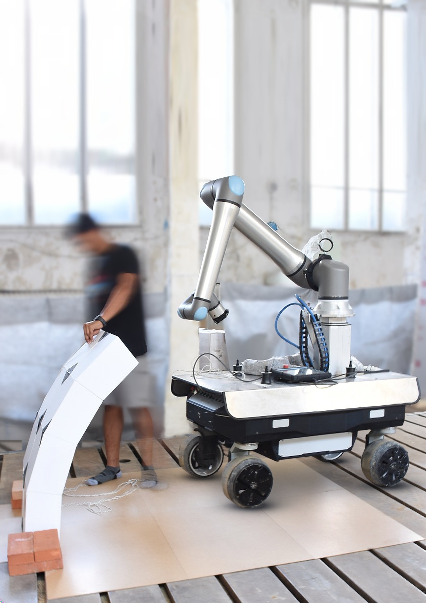

Professorship of Digital Fabrication
Department of Architecture
Technical University of Munich

Digital Fabrication Research Topic WS 2026/27
FlyingRocks: String-Actuated Deployment of Flat Tiled Assemblies
Image: TUM Professorship of Digital Fabrication

FlyingRocks: String-Actuated Deployment of Flat Tiled Assemblies
For students of the programs: Architecture, Civil Engineering, Robotics
Requirements: Interest in robotic fabrication, hands on physical prototyping; basic programming knowledge in Python or a visual programming language such as Grasshopper is helpful
Research Question: How can string actuation transform flat tiled assemblies into vaulted structures, and how can this principle be scaled towards heavy materials such as stone?
Description: The goal of the research is to explore the string-actuated deployment of flat tiled assemblies into vaults. Strings routed through the individual tiles are tensioned by a robotic end-effector, transforming a flat configuration into a spatial vault. The vision is to apply this principle to heavy materials rather than stacking them one by one to achieve the final geometry. You will explore one or more of the following directions:
End-effector: Rethinking the end-effector to make string tensioning more controllable and reversible, and exploring strategies for precise alignment between robot and assembly.
Tile design and fabrication: Developing and fabricating tile assemblies, investigating how geometry, connections and material influence the folding behaviour – with a view to the transfer to heavy stone elements.
Deployment strategies: Exploring alternative ways of deploying the assembly, and how the geometry of the tiles themselves can guide it into its final form.
Through an iterative design-to-fabrication process, you will develop and test physical prototypes, combining computational design, robotic actuation and material experimentation.
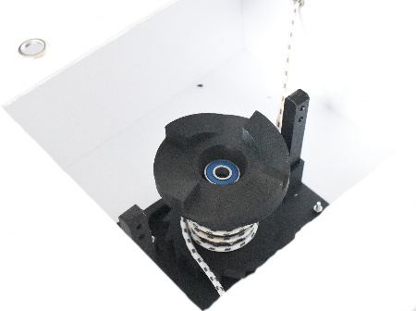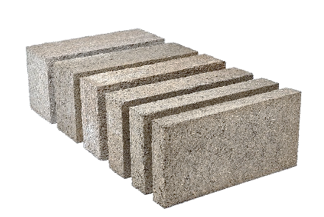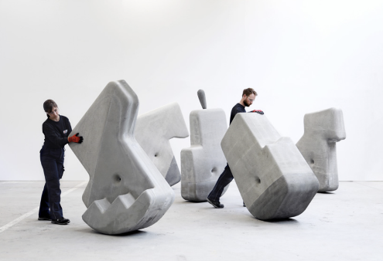
Images:
TUM Digital Fabrication (left)
Hemp Blocks, IsoHemp (centre)
Walking Assembly, matter design studio, MIT (right)

Supervisors: Likhinya KVS
Professors: Prof. Kathrin Dörfler
Contact: likhinya.kvs@tum.de

